15th June Screenshots
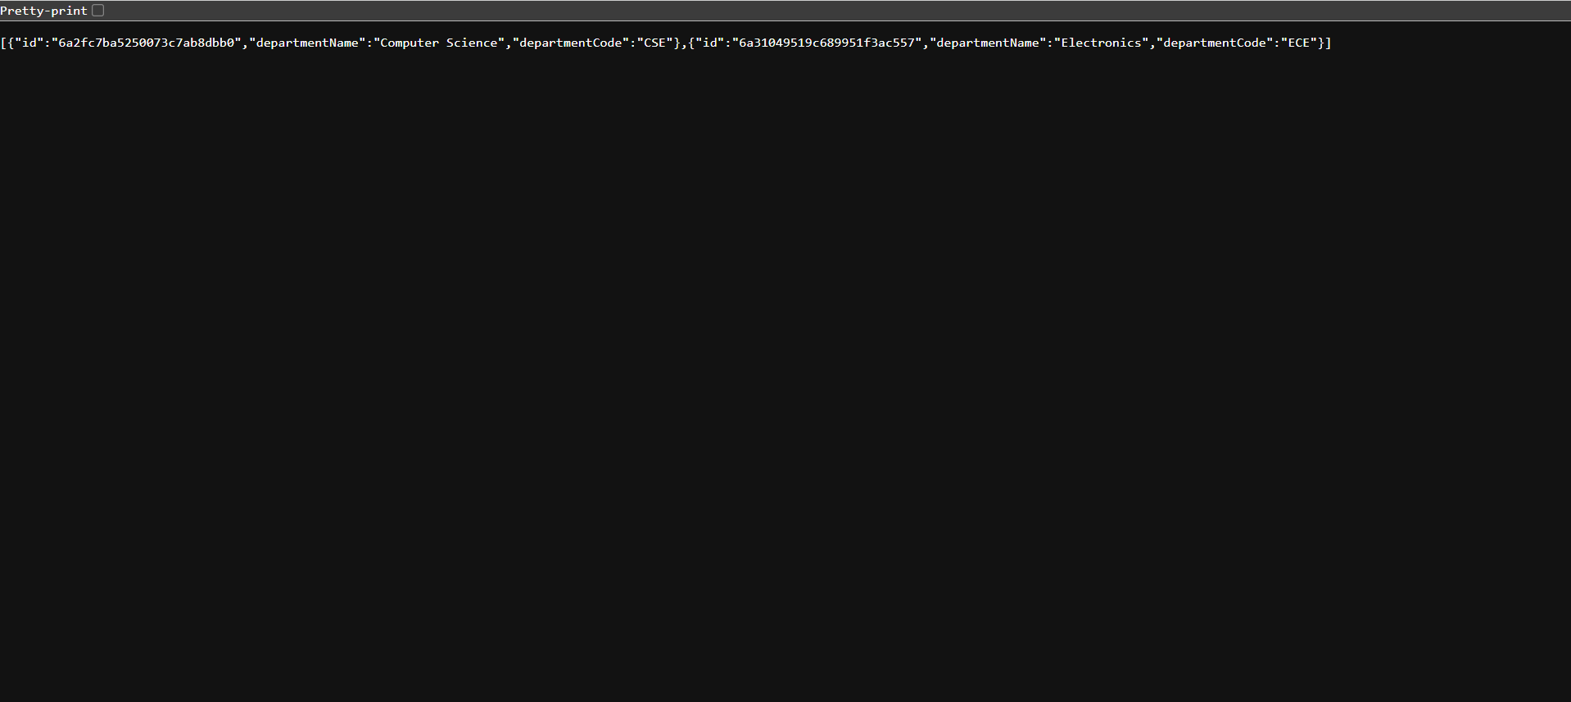
Department API response showing department data retrieved from MongoDB.

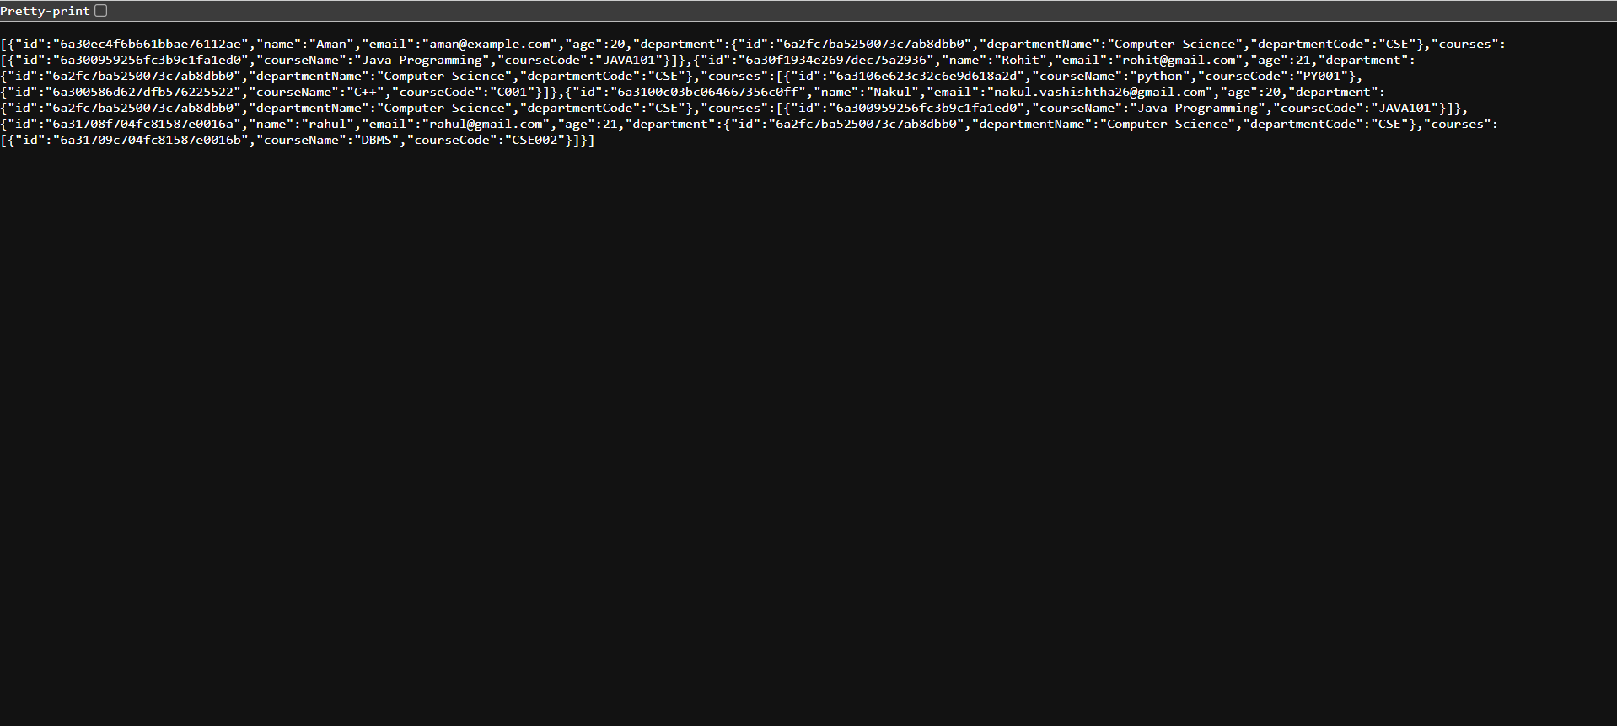
Student API response showing student, department, and course relationships.

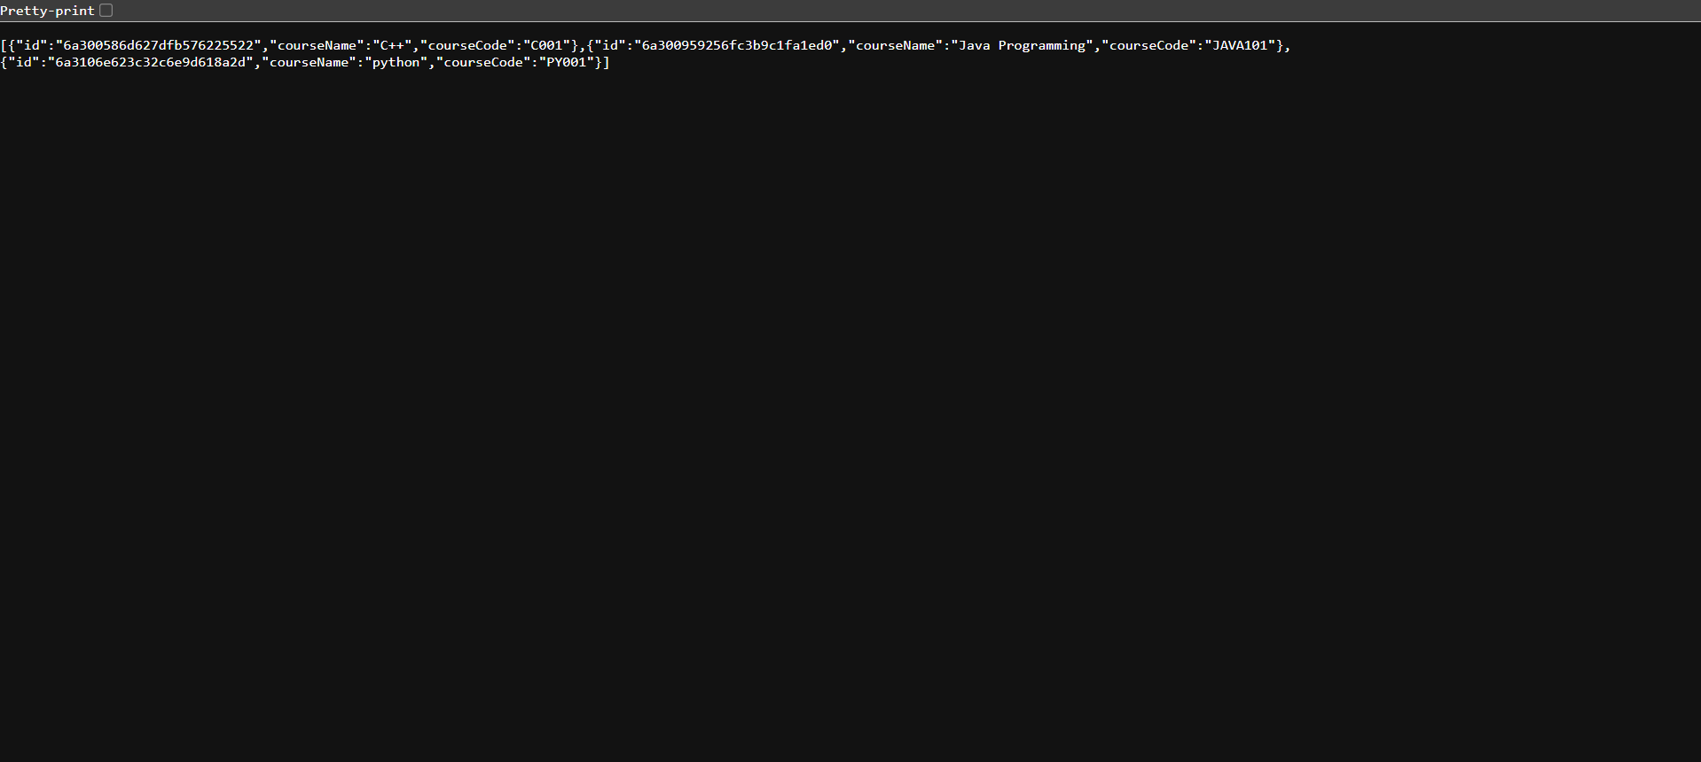
Course API response displaying available courses in the system.

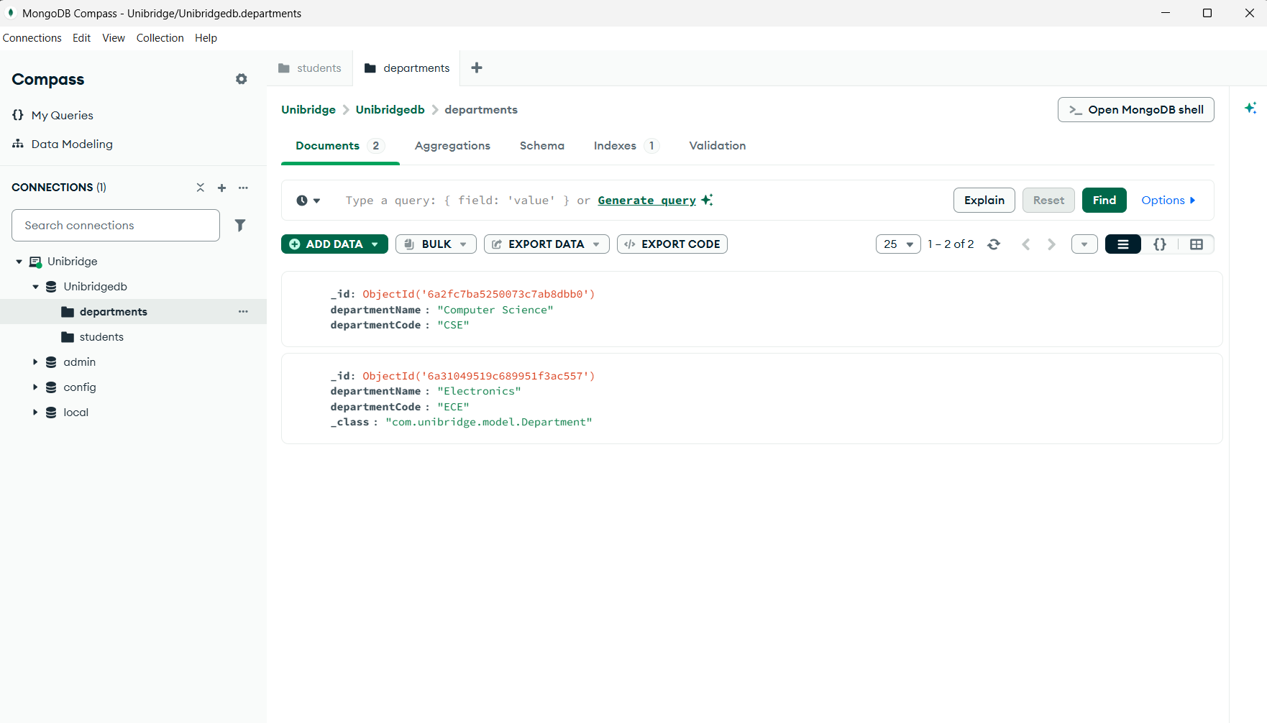
MongoDB Compass view showing department collection records.

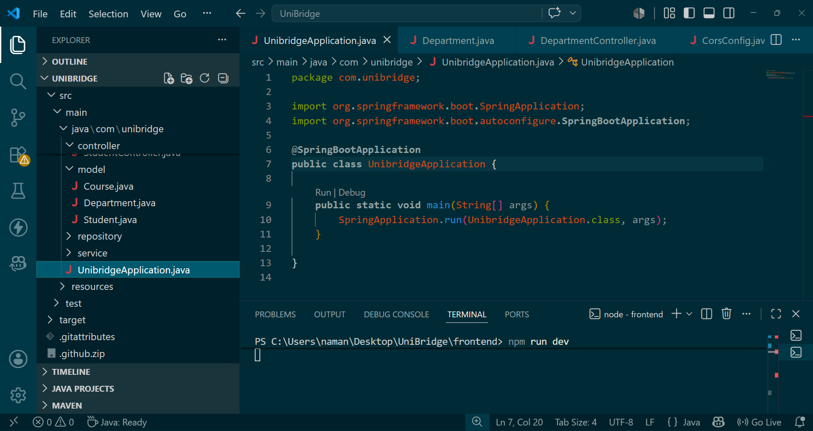
VS Code project structure and Spring Boot application setup.

